Personal accounting

Mastering the noble art of saving is the foundation of financial freedom

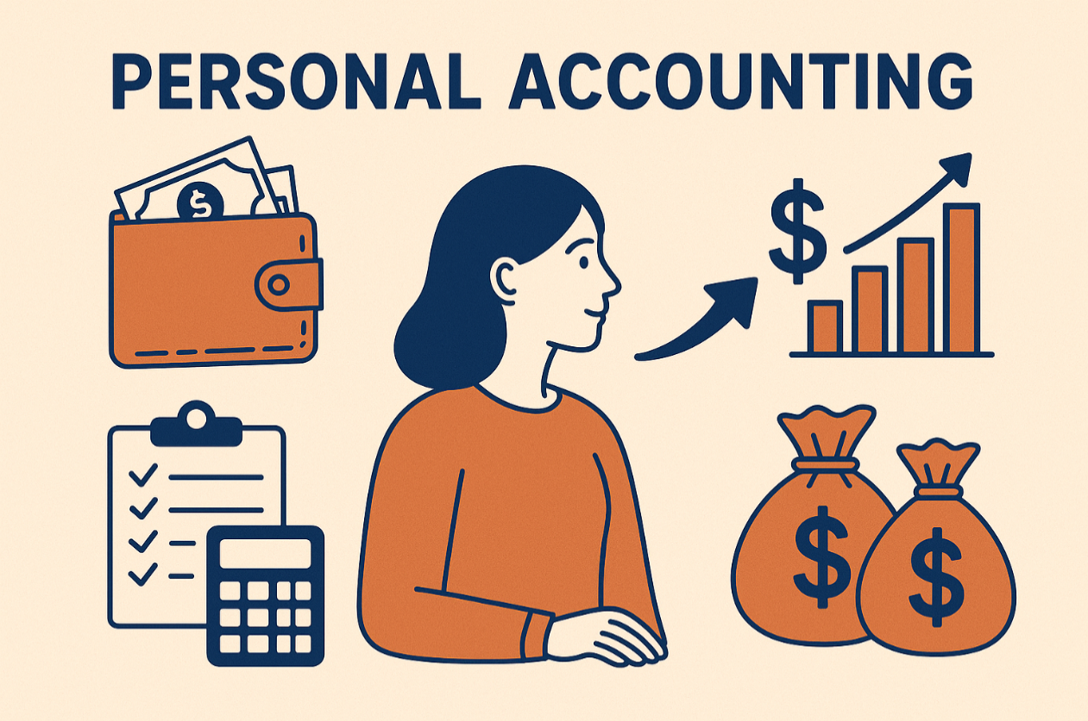

## Start tracking your cash flow

Dear Lit investor,

as you probably know, before diving headfirst into the world of investing, you should **master the noble art of saving** and this article will tell you how I approached the subject.

Since I started working, I have always tried to track my income and expenses, as I wanted to be sure I could start saving some money right away. Not to be obsessive, but to be mindful of where my cash was flowing.

To be completely honest, **at first I was quite obsessive**. Every Sunday I would download all the transactions from my debit card (even the tiniest daily expenses) and log them in an Excel spreadsheet, just like a financial guru would recommend. However, after few months, I realized that it was not really working – at least not for me. Recording everything took too much time and made me **lose focus on what really mattered**. Moreover, I was trying to maximize my savings by cutting out small daily expenses that, in the grand scheme of things, didn’t really make a difference, such as a €1.50 coffee on a Saturday morning at my local café.

**Eventually, I found my method** (example table below). I would say that it works for anyone who wants to track their spending without going crazy:I record only recurring expenses, even if small (e.g. housing, utilities and groceries), and discretionary purchases, only if significant (e.g. fun & vacations and physical goods). I set a threshold of €10, but you can adjust it however you want.



It works for me with very minimal effort. Once the system is in place, it takes just 10 minutes per month and gives you a clear picture of your main income and expense items. **Consistency, though, is the key**. In no time, just the habit of keeping track of my cash flow has made me more disciplined with my spending and more motivated to grow my income.

## How to save more

But now let’s answer the question: “how can I save more?”. This calls for breaking things down into short-term and long-term. For simplicity, **let’s assume** **you are an employee** and these are you cash flows:

* Income:
  + Salary (grey): very sticky in the short term, but can increase dramatically over the years, thanks to promotions or job changes
  + Side hustle (orange): quite sticky in the short term, can suffer seasonality and tends not to scale over time if it remains a “side project”
* Expenses:
  + Non-discretionary (blue): very sticky both in the short and in the long term.
  + Discretionary (green): very flexible both in the short and in the long term.



As a result, the most effective way to save more **in the short term** is to **cut discretionary expenses**. Without too many sacrifices, you can switch from €120 Ralph Lauren shirts to tailor-made ones for half the price. Sounds like a deal, right? By the way, to be honest I think premium brands like Ralph Lauren have been losing a lot of their appeal over the last few years while “no-brands” items have amazing value-for-money.

On the other hand, **in the long term** it is best to focus on **increasing your sources of income**, while trying not to inflate your lifestyle too much. Not too much, but a little, yes. Otherwise, why put in so much effort in saving money?

## Non-monetary benefits of saving money

Of course, saving money gives us more room for future spending and financial security for retirement (sensitive matter for us Europeans), but practicing saving can be beneficial for other things too.

Saving reduces waste and helps us focus on the important things. Once we’ve developed good spending habits, we end up **buying only what we truly need** **or genuinely desire**, resisting the temptations of instant gratification and compulsive shopping (sorry, Flying Tiger).

In “Fight Club”, they say that “the things we own end up owning us” and, even if I may not fully agree, I still think that **the best purchase** we can make with our savings **is the freedom to decide our next move**.